
St Aloysius’ College
Year 9 5.3 Term I Mathematics Assessment
4th April 2018

NAME: ……………………………………………………
TEACHER: ADA JWL/SRO GON IMO

Time allowed: 40 minutes
Total Marks: 42

Instructions:

• Approved calculators may be used.
• All necessary working is to be shown for Free Response Questions.
• Marks may be deducted for careless or poorly arranged work.

SECTION 1: COMPUTATION AND FINANCIAL MATHEMATICS (20 MARKS)

Multiple Choice 5 Marks

For questions 1 − 5, circle the correct answer, A, B, C or D.

- 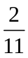 written as a decimal is:

(A) 0.18 (B) 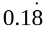 (C) 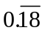 (D) 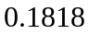

- 750g as a percentage of 3kg is

(A) 250% (B) 25% (C) 2.5% (D) 0.25%

- The number 5.2083 written to three significant figures is:

(A) 5.2082 (B) 5.208 (C) 5.20 (D) 5.21

- If 15% of an amount is $3 000, the whole amount is:

(A) $20 000 (B) $2 000 (C) $200 (D) $18 000

- How much does Jack need to invest, to the nearest dollar, at 6% per annum compounded annually for 3 years to have $15,000 in his investment account?

(A) $15 000 (B) $12 594.29 (C) $12 594.00 (D) $12 595.00

Short Answer 5 Marks

Give your answer only in the right hand column. All questions are worth one mark.

Answer
- Simplify the ratio 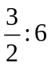 .

- Sam travels 150 km in 2.5 hours. What is his average speed?

- Tom’s usual weekly wage is $725. His receives a 12% wage increase. What is his new weekly wage?

- Divide $135 into the ratio 7:8.

- Calculate the interest earned on $5 500 if it is invested at 4% p.a. compounded annually for 2 years.

Free Response Questions 10 Marks

All necessary working is to be shown.

- What is the value of an investment of $10 000 at 5.25% p.a. simple interest after 3 years. 2

- Ben’s income for a particular week was $687.96. He is paid $16.38 an hour for 34 hours, and 3
double time for any hours worked after that. Calculate the number of hours of overtime
he worked in that particular week.

- Alexander is taking 4 weeks annual leave. For his holiday period, he is paid $5076. This 2
includes his normal pay plus 17.5% leave loading. Find his annual salary.

- In a particular country in 2016, 85% of the population are employed, whilst the rest are 3 unemployed. The following year 10% of the unemployed became employed, whilst 10% of
the employed became unemployed. What percentage of the population are employed in 2017?
Hint: let the population be 1000.

.

END OF SECTION 1
St Aloysius’ College
Year 9 5.3 Term I Mathematics Assessment
4th April 2018

NAME: ……………………………………………………
TEACHER: ADA JWL/SRO GON IMO

Instructions:

• Approved calculators may be used.
• All necessary working is to be shown for Free Response Questions.
• Marks may be deducted for careless or poorly arranged work.

SECTION 2: ALGEBRAIC TECHNIQUES AND INDICES (22 MARKS)

Multiple Choice 5 Marks

For questions 1 − 5, circle the correct answer, A, B, C or D.

- Expand 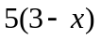:

(A) 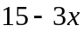 (B) 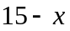 (C) 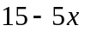 (D) 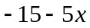

- Solve 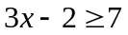
(A) 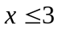 (B) 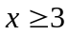 (C) 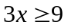 (D) 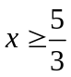

- How many solutions are there to the equation 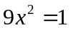?

(A) 4 (B) 0 (C) 1 (D) 2

- Factorise the following expression 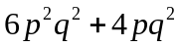:

(A) 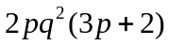 (B) 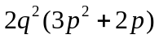 (C) 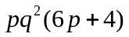 (D) 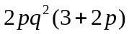

- Simplify the following expression 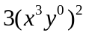

(A) (B) 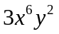 (C) 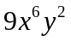 (D) 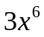

Short Answer 6 Marks

Give your answer only in the right hand column. All questions are worth one mark.
Answer
- Solve 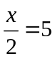

- Solve 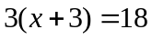

- Expand and simplify 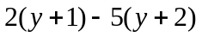

- Solve 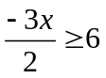

- Solve 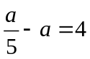

- Make a the subject in the following formula: 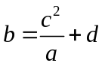

Free Response Questions 11 Marks

All necessary working is to be shown.
- Simplify the following expression: 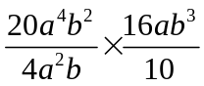 2

- A classroom has a width 6 m shorter than its length and a perimeter of 30 m. Find the
dimensions of the classroom by first constructing an equation. 3

- Solve the following simultaneous equations: 2

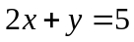
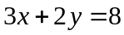

- For a certain fraction, if 1 is added to the numerator and 1 is subtracted from the denominator 4
the result is 1. For the same fraction, if 1 is subtracted from the numerator and 1 is added to the denominator the result is 3 . By first forming simultaneous equations, find the fraction.

END OF ASSESSMENT

